Block Ram Image Viewer
User’s Manual
By Zoltán Ulrich

This document is part of the “Block Ram Image Viewer” project, submitted for the second edition the Digilent Digital Design Contest. It contains instructions for setting up and using the software and the hardware needed for the project.

- Hardware requirements and setup

For running the project the Digilent Nexys Board is needed. Any of the Nexys Boards will run the project, no matter the size of the FPGA: Spartan-3 200kgates, 400kgates or 1000kgates. The project was designed and tested on the 200kgates board: xc3s200-4ft256.

Requirements for running the hardware part of the project:

- Digilent Nexys Board
- 2 ps/2 modules
- 12 bits per pixel vga module
- crt monitor (also works with TFT)
- ps/2 compatible mouse
- ps/2 compatible keyboard

The project should run on any other Spartan-3 board that has 2 ps/2 connectors, 4x7-segment displays, a 12 bit per pixel vga module and can generate a clock of 100MHz, by modifying of the ucf file. To run on a board that does not comply to the above requirements, some changes in the code must be made, like changing the number of bits the image is represented on if the vga module doesn’t use 12 bits per pixel, the 7-segment decoder must be changed if the board does not have 4 7-segment displays, or the segments have a different polarity. The project can run with no or only one connected ps/2 device, but functionality is significantly reduced. The board must have a Digilent Communication Module for the dpcutil library to be able to exchange data with the board through the epp interface. Read DPCUTIL Programmers Reference Manual for further information.

The ps/2 connector for the mouse must be plugged in the leftmost 6 pin extension connector (JA) and the keyboard ps/2 connector must be plugged into the second 6 pin extension from the left to right (JB) unless the ucf file is changed.

To load the bit file onto the FPGA the Digilent ExPort program (part of the Digilent Adept Suite) must be used. After initializing the chain, the briv.bit must be loaded and selected in the drop box associated to the FPGA. Press the Program Chain to configure the FPGA. The Adept Suite can be obtained from:

http://www.digilentinc.com/Software/Adept.cfm?Nav1=Software&Nav2=Adept
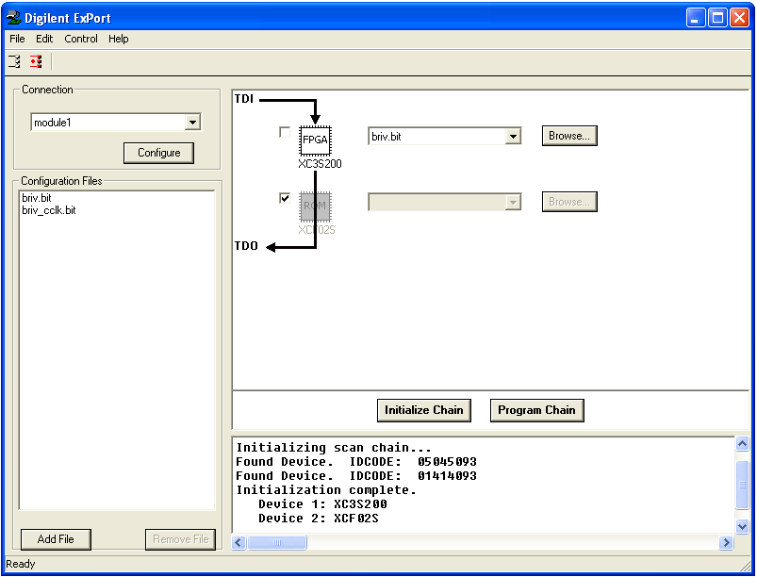

After this is done, the FPGA is configured and the project starts running. The monitor should start up in the 640x480@60Hz resolution. The mouse cursor should be centered and the screen should be white. The leds on the keyboard should work when pressing num lock, caps lock or scroll lock. Also the resolution should be possible to change by pressing the ctrl + 1 key combination for 640x480 resolution and ctrl + 2 key combination for 800x600 resolution. The cursor should move on the screen when the mouse is moved.

If the monitor doesn’t start, check the vga connections and make sure the project is running at 100MHz. If the mouse or the keyboard doesn’t work, check the connections and make sure they are plugged in the corresponding 6 pin extensions as described above. Also, the keyboard might need +5V to function. In this case, move the jumper next to the keyboard 6 pin extension so that it connects pins VA and VU.

- Software requirements and setup

The computer must run Microsoft Windows XP operating system with service pack 1 or higher and must have installed Microsoft .NET Framework 2.0. dpcutil.dll library must be in the library search path of the program (most likely in the program directory or the system32 directory). For the webcam to be accessible, the Windows Image Acquisition framework must be installed and the WIA service must be running (implicitly the service is started automatically by the operating system). Also the WIA Library v2.0 is required. This library can be downloaded from Microsoft’s website:

http://www.microsoft.com/downloads/details.aspx?FamilyID=a332a77a-01b8-4de6-91c2-b7ea32537e29&DisplayLang=en

After downloading the sdk, extract wiaaut.dll from it and place it in your system32 directory. Open a command prompt window and type the command:

regsvr32 c:\windows\system32\wiaaut.dll

Please adjust the path in the command to reflect the path to the system32 directory on your computer, if necessary. You can also do this by running the batch file (runme.bat) in the software folder. The project works even if there is no WIA compatible video device found, but the video stream feature will not work.

3. Using the software

Before running the program, make sure that the board is programmed with the bit file and it is connected to the computer. The program uses the dpcutil.dll library and because it doesn’t use transactions, no other program that uses this library can be run simultaneously with the program. When the program starts, it tries to initialize the dpcutil.dll. If it fails, it displays a message box informing the user of this and then exits. It then gets the number of devices registered with the dpcutil library. If there are no registered devices, the application starts the dpcutil registration window. If a device is registered, the application continues, else it exits. If only one device is registered, then the application uses this device, else if more than one modules are found, the application displays a dialog form to choose one of the modules.

If a camera ID is stored in the application settings, then the application tries to start the webcam. This might delay the application a few seconds. After this is done, the main form appears.

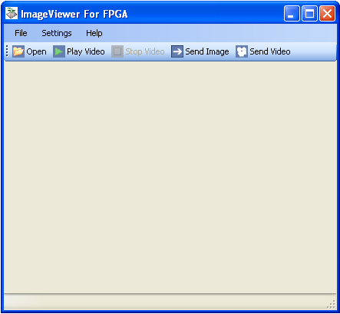

Now you can load images into the application and they will be displayed on the main form. Supported image formats are bitmaps (*.bmp), jpeg files (*.jpeg, *.jpg), gif files (*.gif), png files (*.png), and tiff files (*.tif, *.tiff). The image is loaded, the form is resized to fit the image and if the form is manually resized, the image remains centered. On the status bar, the name of the image is displayed together with the image dimensions and number of bits per pixel. When video is displayed, the status bar displays the frame rate.

You can load an image from the File menu with “Open Image File” menu item, or you can load an image by pressing open button on the toolbar. Recently accessed images are available for quick reopening in the File menu. An image can be captured from the webcam by selecting “Image From Webcam” menu item in the File menu. To start displaying video from the webcam on the form, you must select “Start Video From Webcam” menu item from the File menu, or press the “Play Video” button on the toolbar. To stop the video feed, select “Stop Video From Webcam” (now enabled) from the File menu, or press “Stop Video” button on the toolbar.

Once an image is loaded you can sent it to the FPGA by pressing “Send Image” button on the toolbar. If the image has a different number of bits per pixel than 24, the image is converted to a 24bpp image and then sent. You cannot send images that have the width less than 4 pixels. Before sending the image, it is resized (if necessary), maintaining approximate aspect ratio, to fit the memory on the FPGA, that is to have at most 16384 pixels.

By pressing the “Send Video” button on the toolbar, it remains pressed, and when video stream is enabled, it automatically sends the images to the FPGA. If the “Send Video” button is not pressed, the images from the webcam are not automatically sent to the device. You can send an image from the stream to the FPGA by clicking “Send Image” button.

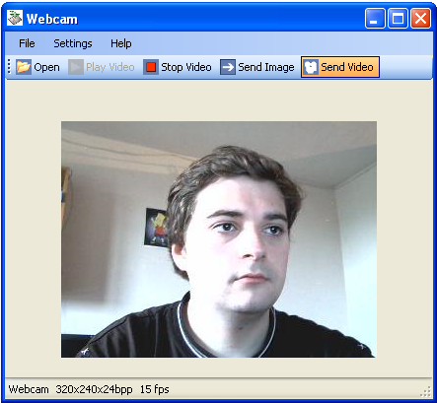

From the Settings menu you can select the video device to use, the selected device ID is stored and the next time you start the application, it will initialize this device, if the application can find it. Also, from the Settings menu you can select the “12bit Display”, which makes the image displayed simulate a 12bpp image, as shown on the monitor connected to the FPGA.

When an image from a file is selected, you can change the displayed image by pressing space key and the next image (alphabetically) in that folder is displayed. If you press backspace key, the previous image is displayed. When browsing images in a folder and reaching the last image, if space is pressed, the first image will be displayed. Similarly, when browsing backwards and reaching the first image, by pressing backspace, the last image will be loaded.

When browsing, the index of the currently displayed image and the total number of images in the folder are displayed in the status bar.

Images can be changed from the keyboard attached to the FPGA similarly to the way they are changed on the computer. By pressing space key, the next image is requested from the computer, which loads and sends this image. By pressing backspace, the previous image is displayed on the monitor connected to the FPGA. You cannot load a specific image from the FPGA; you can only browse images in the folder of the currently displayed one. By pressing ‘Q’ key, the video stream is started and sent to the FPGA and to stop it, ‘A’ key must be pressed.

From the FPGA you can apply the negative, grayscale or both effects to the displayed image (this also applies for video streams, which are just a sequence of images). By pressing the ‘N’ key, the negative effect is enabled and all the images displayed on the monitor from now on have this effect applied to them. To stop applying the negative, ‘N’ key must be pressed once more. The ‘N’ toggles if the negative will be applied or not. Similarly, the ‘G’ key enables the grayscale effect on the displayed images. Both negative and grayscale effects can be applied simultaneously. These effects apply only to the images displayed, not to the background and the mouse cursor.

With the mouse you can move the images on the screen, by clicking (with the left mouse button, or the right one) somewhere inside the image and with the mouse button pressed, move the mouse around and the image will follow. The image will remain at all times entirely in the visible area even if you try to drag it outside. The image can also be moved by rolling the mouse wheel (if it has one). When rolling the wheel, the image will move vertically on the screen with an increment of 8 pixels in the direction it is moved. To move the image sideways, the middle mouse button must be held down while rolling the wheel.

When an image is sent, it is centered by the FPGA, so when sending video from the webcam, the image can be moved around with the mouse, but when it is released, the next image sent will be centered again. Also, when changing the display resolution, the image is centered, even if the resolution selected is the same as the currently used one.

To change the display resolution, the CTRL + 1 key combination must be pressed on the keyboard connected to the FPGA for the 640x480@60Hz resolution to be selected. For the 800x600@60Hz resolution, the CTRL + 2 key combination must be pressed. These are the only two selectable resolutions. The resolution cannot be changed from the computer.

Important:

- Before starting the application, connect the board to the computer, otherwise the application won’t be able to establish a connection to it, and will exit.
- Before sending images to the FPGA make sure that the board is connected to the computer, it is powered up and has the design loaded onto it.
- Do not reset or power off the board while a video stream is being sent to it.

